SUGGESTIONS MADE IN THE WEST ZONE CORE COMMITTEE WORKSHOP CONDUCTED BY SNEA(I), ON 06-07-11 AT HOTEL ANNAMALAIYAR, NEAR NEW BUS STAND, VELLORE:

CSC

- Earlier CSC's and franchisees were supplied with UNIFIED SIMs, which can be activated within seconds. Now RECON sims are being supplied . Activations procedure consumed 20 to 30 minutes. Even though RECON SIMs are good, much delay noticed in activation. While conducting Melas and Road shows it is difficult to answer the questions of prospective customers. This is affecting Brand iamge also. Hence procedure for activation of RECON SIMs should be made easy. For Melas and Road shows USIM shall be supplied like other circles.
- All CSC should be given access to Pay-One FX module for accepting Mobile / WLL bills online. By extending this facility re connection problems will also be solved.

- Mobile and WLL bills paid through CDR PMS module. Delay noticed in updation of payments from CDR server to Kenen FX server.

- Like Prepaid Postpaid Number selection and SIM replacement shall be made simple. Possibility of doing postpaid activities in Sanchar-Soft shall be explored.
- Frequent recharge problems regarding Ctop UP. Reversal mechanism of C-top up shall be made more effective.
- To know about offers and New plans USSD menu ( just like *123# ) may be implemented.

- In consumer mobility any plan to any other plan change over shall be made permissible.

- Availability and sale of SIM cards, RCV’s and TOPUP in all CSCs / CCCs / CSRs should be ensured . Still there are CSCs in which only Bill collection alone is being carried out.

- In case of bundled offers ( 3G / 2G ) - Good looking and latest model handset models should bundled.

- Facility to change the FFL ( land line indicator ) of ENNANBAN Plan may be introduced at least after six months from the date of activation, Subscriber is ready to pay for this. at a cost

- Validity voucher for 2G special and 3G special plan may be given to retain the customers

- ALL CSC / CCC / CSR working hours should be 8 am to 8pm.
- Tamilnadu Circle with 17 SSAs consisting of 122 SDCAs is catered by only around 200 CSCs and 80 extension counter(s). More number of CSCs is to be opened to serve/redress our customer grievances. As a first step, the extension counters are to be upgraded to the level of CSCs and sufficient number of CSCs should be opened so that customers should walk-in to the CSCs and get the BSNL Services & complaints redressed.

- Continued motivational classes to be conducted by SSAs to the staff working CSCs. The staffs working in CSCs are to be provided with all the instructions/guidelines given by Circle/Corporate Level and updated knowledge about all revision/changes made now and then.
.
MNP:

- Majority of the MNP Port in cases are getting failed as "Porting Code wrong" or "Contractual Obligation error". Regarding Airtel, almost 60% are getting rejected.

- As for as MNP is concerned publicity should be still more. Retailers should be given more commission for MNP Portin cases cases.

WLL:

- WLL prepaid portal to be introduced for CSC's. Plan Migration module in CCM is not working.
- Scarcity of EVDO / NIC cards to be addressed.

GSM:
NWOP-CM

- Spare Cards availability for GSM Equipments must be ensured for less outage of service
- Quality of the Infra materials should be ensured
- CM Wing must be strengthened. Transmission wings of SSAs shall be strengthened to reduce the outages of the BTSs. All BTS shall be brought under the transmission rings
- USO site maintenance - Maintenance by Electrical wing . Proper co-ordination with SSA maintenance to be ensured to minimize the BTS outage.
- Staff of BSS wing should be increased for proper maintenance
- CMTS-IMPCS and NWOP-CM wing’s co-ordination is must to address cases of no coverage and poor coverage problems.
- Before any tender implementation especially in BTS’s a model site must be put by the vendor as per the tender and all the infra items must be tested rigidly for quality to have smooth maintenance in future
- It is suggested that in forthcoming tenders Turnkey projects shall be avoided and equipments alone may be purchased. Infra items can be purchased by BSNL separately and installed by BSNL.
- Circle planning may analyze the connectivity for the node B’s in IP platform. A clear cut strategy may be worked out for every site. Since the number of ports available in NIB is less, we may explore the possibility of providing aggregator.
- Coverage issues should be sorted out by upgrading equipment/expertise.
- Network congestion should be avoided
- By expanding the 3G Network all customers can be given 3G facilities – Existing confusion between 2G & 3G services is to be eliminated.
- Data Plan customers are being provided with email id in Mail server of bsnl.co.in which is not being used by customers since the same is not user-friendly and not working efficiently viz. auto save, file attachments, loss of message while in preparation etc.

IP sites:
Several IP sites are working in unimportant and unwanted areas. These should be identified and further extension shall be stopped. Also possibility of closing of closing IP sites which is earning meager revenue which is not sufficient for operating cost itself must be analysed. If possible these loss making IP sites shall be closed and an alternative method to cover this area may be explored (like repeaters / boosters from other nearby site). In future IP sites may be planned only in urban areas where we can earn revenue.
VAS content providers must be integrated with the Service Delivery Platform ( SDP ) for hassle free service to the customers.
At present TN BSNL Live, BSNL Streaming services, etc are routed through Service Delivery Platform ( SDP ) but content providers (Onmobile, Apalya, Minimobitv, etc.,) are not routed through SDP.By routing through SDP customer’s complaints can be analyzed from a single platform and also some control will be there over the Content providers. Most of the customers are complaining that content services are activated by Content providers without their knowledge in the name of out band dialing. One of the main reason for porting out is cheating subscribers by the content providers. It is tarnishing the brand iamge also. Since CPs are not integrated with SDP, we are not in a position to analyze the data and also complaints. Hence VAS content providers must be integrated with the Service Delivery Platform ( SDP ) for hassle free service to the customers.

VAS Deactivation & Activation and Changes shall be taken through CALL CENTRE until the Service Delivery Platform (SDP) is launched in South Zone.

( Note on Service Delivery Platform (SDP)

What is SDP?

- It is a common platform where all the network elements are integrated
- SDP Provides various bearers for service Access to Subscribers
- SDP Interacts with various Content Providers through Adapters
- SDP is Accessed from the internet by Subscribers/CP’S/ASP

Why it is required?

- Existing VAS are independently connected to network elements (prbt, mobile radio, MMS etc.)
- Not possible to analyse status of data on a single platform
- Simplifies the complexity of the network.
- Ease of operation.

Need for SDP

- All content providers are connected at a single Platform
- Generation of single MIS report.
- Revenue Sharing and Bills Settlement can be done easily
- Centralized Service Creation
- Operator Control on the Services to end Subscriber )

Problems faced by subscribers while in International Roaming :

Our esteemed, international roaming customers are not satisfied with our service due to the cumbersome procedures involved.

How International roaming (IR) implemented in BSNL:
BSNL implemented IR through Roaming Replicator, Which allows an operator to “piggyback” onto another network’s existing roaming relationships. Roaming Replicator is a SS7/MAP node with full SCCP capability

Inbound Roaming
Roaming Replicator makes the ‘Foreign Network’ thinks that its subscriber is roaming in ‘Partner Network’.

Outbound Roaming
Roaming Replicator makes the ‘Foreign Network’ thinks that the ‘Partner Network’ subscriber is roaming in its network.
BSNL has been using triple IMSI (IMSI of Spice, IMSI of WB LSA and IMSI of home LSA) SIMs for facilitating international out roaming to BSNL subscribers. International Roaming customers have to follow the following procedure through STK to get roaming service in foreign.

STK (SIM Tool Kit) application for international roaming.
1. After landing into foreign country, switch ON the phone and go to Menu.
2. Click on Cellone or BSNL Mobile and select Network.
3. In the network you will get option of National and International.
4. Select International, you will get CellOne and Partner Network.
5. Select the option Cellone; you will get a message - "CellOne International
Selected".
6. Wait for two minutes you will get the Network automatically.
7. If it fails, please select the network manually. (By selecting Setting and then
Network in your phone).

Problems with international roaming in piggyback method instead of direct roaming:
- Before leaving to the foreign country, customers have to personally visit our CSCs to change his single IMSI SIM to Triple IMSI SIM.
- Customers have to do the messy exercise of network selection.
- Serious problems of using triple IMSI instead of Single IMSI:
The agreement for 'Roaming Service on revenue sharing arrangement' with M/S Idea Cellular Limited (erstwhile M/S Spice Communications Limited)' was expired on 3I-07-2010. At present, only direct bilateral international roaming arrangement exist and West Bengal (INDWB) continues as nodal circle. Hence BSNL customers availing International Roaming Services require only dual IMSI i.e West Bengal LSA like IMSI in addition to IMSI of its home LSA in the SIM. The Spice like IMSI, as available in existing triple IMSI SIMs became in-effective after 3l-7-2010. But still our customers are using triple IMSI SIMs hence the international roaming customers getting the following Menu.

Menu Step 1 | Step 2 | Step 3 | Step 4
CELLONE or BSNL MOBILE >>>> | National
 | International | Cellone Network | West Bengal IMSI
 |  | Partner Network | Spice IMSI (Invalid)

CELLONE or BSNL MOBILE >>>> International>>>>Partner Network >>>>Spice IMSI (Invalid). Most of the time the customer is selecting the invalid partner network IMSI. Hence the customer is not getting International Roaming. Many customer care centers are not aware of this problem. Our esteemed High ARPU IR customers are very annoyed and slowly porting out to other operators. BSNL CO already issued order vide No 55-14/2008-CMTS (Pt-II) dated 28-07-2010 to procure dual IMSI SIMs, but till date the customers are using Triple IMSI SIMs only.

What our competitors are doing:
Our competitors having direct roaming agreement for the international roaming. Hence their customers are very comfortable and feeling like in home, No need to follow any network selection procedure after landing in foreign country. Many of our customer having alternate number with our private competitor hence they are bitterly complaining about why BSNL only creating so many problems in international roaming.

Leading questions to be answered:
- Why BSNL is not having direct roaming agreement for all circle SIM ranges? If the answer is Signing international roaming agreements for all circle SIM ranges is laborious process, How our competitors are having such agreements?
- Why still we are using Triple IMSI SIM cards instead of Dual IMSI SIM cards though it is evident that it is creating great confusion among the IR customers from 31.7.2010?
- What is the problem in procuring dual IMSI SIM cards?
- Why it was not done even after one year of order vide No 55-14/2008-CMTS (Pt-II) dated 28-07-2010 to procure dual IMSI SIMs?

Problems in Barring of call forwarding to other operators number

Hitherto, Forwarding from BSNLs Mobile number to any other operators mobile number within the LSA is permitted as per BSNL CO order number No. MOB-16/Opn-2006 Dated 04-8-2006. Many BSNL customers are enjoying this facility. We are also getting double revenue for both originating leg and terminating leg. If A and B are BSNL and B forwarded the call to C, Where C is other operator. BSNL is getting revenue for A to B and B to C. Private Operator also getting revenue for B to C call termination.

Now, BSNL CO Decided to restrict call forwarding with in BSNL and within LSA (Including ported in and non ported numbers) vide BSNL CO letter No. MOB- 16 / Operations - 2011 Dated 4th July, 2011. If this order is implemented, it will deeply embarrass our esteemed customers and BSNL may also lose the revenue.

Difficulties in implementation of this order:
It is not possible to prevent the customers from registering call divert to the private operator level in HLR, because in the MNP scenario any level number can be ported to any operator. We can only bar the forwarded call in MSC/GMSC based on LRN (Location Routing Number). This will invite many complaints from dissatisfied customers because customer can able to register call divert to operator but actually call divert will not happen.

Leading questions
- What is the necessity to the barring of call forwarding to other operators number?
- What are the benefits to the BSNL?

Frequent failure of GSM Net work Elements (NEs) due to the poor planning of transmission media connectivity.

GSM Net work Elements (NE) like MGWs ( Media Gate ways ) are connected to the core N/W via active and standby connectivity. But it seems that in some cases both active and standby connection is extended through the same route and same equipment, which leads to total blackout during transmission failures. Transmission media connectivity route audit shall be done to settle this problem.

Under utilization of 4.5 m Huwei – IN installed at Bangalore and Hydrabad:

` Two 4.5 million capacity Huawei IN with new features were installed one at Bangalore and another at Hydrabad long back. Till date re distribution of subscribers was not carried out due to vendor non co-operation. Huge number of capacity with new features are kept idle in these Huwei INs. At the same time other INs in southern states are heavily loaded and creating frequent problems which leads to poor customer satisfaction. This problem is to be addressed to Corporate office and action shall be taken against the vendor under tender clauses for non co-operation. Re distribution is to be carried out immediately and proper vendor support is to be ensured after re distribution.

CONSUMER MOBILITY VERTICAL:

PRODUCTS & PRICING - GSM MOBILE:
TN Circle has recently rationalized the prepaid plans in GSM mobile services as per BSNL Corporate Office. Though the rationalization is believed to bring in a positive effect, it is suggested that the following aspects should also be considered for implementation to get more advantage to BSNL in the prevailing marketing conditions:-

- Unlimited data Recharge Vouchers RCV(s) with longer validity to be resumed.
- Unlimited SMS Plans / Special Tariff Vouchers (STVs) i.e. Boosters to be resumed.

SALES UNIT OF CONSUMER MOBILITY :

- BSNL Franchisees should appoint sufficient number of FoS as per S&D policy and ensure supply of BSNL products to the Retailers under them. In rural areas our product availability in the retail outlets should be ensured Suitable action should be taken when the set target has not been achieved by Franchisees/Retailers/DSA/OSS by Heads of SSA concerned.
- The Retailer incentives can be paid in the form of RCV / Topup.
- Monitoring of services rendered to the Retailers by franchisees is being done through the Retail Managers of SSAs. The feed back report are to be analyzed properly and action shall taken to improvise the retail network ( Like Karaikudi SSA ). As many as Trade Schemes shall be announced to motivate the private distribution channels viz. Franchisee and retailer for the promotion of sales.

GSM-VAS RELATED POINTS:

- STANDARD COMMON SOFTWARE FOR SCRUBBING MOBILE NUMBERS WITH NCPR/PCPR DATA TO BE SUPPLIED BY BSNL: SMS campaign is found to be very cost effective activity for publicity without incurring any extra expenditure. Similarly, Telemarketing is also being carried out by BSNL on commercial basis. In this connection the scrubbing of mobile numbers with the NCPR / PCPR data is to be done frequently to comply with the TRAI guidelines. Standard and uniform scrubbing software across the country should be provided by BSNL since it involves heavy penalty clause as per TRAI.

- As SMS is the only internal source of marketing for the Basic services as well as Value added services. Whenever messages are to be sent to all BSNL customers, the High speed SMSC should be directed to execute it to avoid delay. Other (special lists) SMS campaign may be done by marketing section, for the effective usage of the available sources.

- Now a days customers are asking for bulk sms to a particular city / town. This can be envisaged by using offline server data (to get the customers of the particular city / town). Un utilized servers of closed Ericson IN ( Coimbatore) can be utilized for this purpose.

PROVISION OF SUFFICIENT FUNDS UNDER BUSINESS PROMOTION & MARKETING (BP&ME) ACTIVITIES:

- The fund under BPME was drastically reduced during the month of September 2010. All Marketing Advertising / Campaign activities were made stand-still. The presence of our BSNL was not felt due to “No Marketing Activity” during the last 10 months. For the financial year 2011-12 only around 4.23 Crs have been allotted to TN Circle against the budget projection of Rs.16 Crs. With this 25% of the projected funds no ATL (Above the Line) activities viz. release of print/electronic media advertisements, hoardings etc. could be carried out for publicity. Only BTL (Below the Line) activities like distribution of pamphlets, hand bills etc. are being carried out to publicize our products/services. Sufficient funds shall be provided for BP&M activities and the financial restrictions are to be analyzed and it should be in a realistic manner to meet out the cut throat competition faced in the market with other operators.

- The BSNL outlets and other distribution channels like Franchisees/ retailers/ DSAs etc are not being supplied with sufficient information through pamphlets, brochures, posters etc as is being done by competitors. Due to the prevailing financial hurdle printing and supply of POP materials is not being arranged by Marketing Units of SSAs / Circle.

Call centre:
At present Mobile Call Centre at Chennai caters to the need of mobile subscribers’ complaints & enquiries through 1503. It is felt that all subscribers that the service offered at Call Centre is very poor. The present outsourced call centre employs personnel with qualification only 10th STD or Plus-2. Because of lack of knowledge and experience, satisfactory service is not being provided by the Call Centre.

We may segregate the call centre services as Enquiries and Complaints allotting 2 different numbers i.e. 1503 for enquiry and some other 4 digit number for complaints. We may be able to provide better service to the subscribers with well experienced staff through CSCs and through SSA-/Circle Nodal Units. The complaints calls pertaining to an area on dialing 1503 may be routed to CSC of that area. One CSC may be earmarked for handling complaint in each SSA. For enquiries the common IVRS at one of MSCs may be commissioned and the information may be updated periodically by using the services of our Staff. In this arrangement, we may require routing arrangement on technical side and posting of experienced and courteous staff on administrative side.

Low Cost routing of ISD traffic :

For the past two years the ISD customers are charged in the ringing phase itself. This is only because of our Low Cost Routing policy from our corporate office. So the routes where ever the problem persists it may be changed to a premium route to resolve the issue. By this LCR we have already lost our ISD revenue and also brand image.
CFA:
External unit should be a vibrant unit since it is the delivery Point for customer after CSC. The following suggestions can be implemented:

- Since our TMs are the front end employee, they should be motivated to meet the customer often and especially at the time of attending faults. They should create the impression that customers are being cared.
- During his visit the TM can also function as an marketing person and ascertain the customer’s requirements if any, and become a lead generator. Some incentive points can be given if the lead materializes subsequently. The line staff can also be compensated in the form of basic reimbursements. Broadband /BB VAS /data card etc. can be promoted during his visit.
- As already instructed by the Corporate office, each land line connection should be mapped with a mobile number. Top priority is to be given in the field for completing this mapping. In case of fault of LL indicator, the possibility of giving call diversion at free of cost of faulty indicator to the mapped mobile indicator may be explored. The status of fault clearance and monthly billed amount etc. shall be forwarded through SMS.
- Landline / BB complaint booking through SMS.
- Each unit should work for churn management/analysis of ‘zero’ meter reading cases of VPTs/Telephone Lines and especially BB connections.
- Fault booking of BB/clearance should be closely monitored and should be escalated.
- For all BB customers all BSNL marketing information can be sent through e mail. As per corporate office instruction e mail id of each sub is to be mapped in CDR. Telephone bills can be sent through e mail thus we can save the amount being spent for postage. Field units of SSA’s has to complete the job at the earliest.
- Customers making more number of calls can be offered with UITC card /
or free talk time for the mapped mobile indicator as a compliment.
- More BB usage customers can be offered EVDO/Data cards.
- A separate task force for clearance of BB fault in urban areas to be formed so that the fault can be rectified within an hour.
- As per corporate office instruction to clear cable fault a separate
- task force at SDCA H/Q level is to be formed under JTO/SDE.
- Prompt delivery of Telephone bills is to be ensured which causes huge voluntary closures.
- All PSU employees may be given confessional tariff to prevent surrender of LL and BB..
- In the field units display boards depicting clearly the contact numbers of staff addressing and attending customer grievance shall be displayed in all offices and Exchange premises.

Training Centre

- Power off the model exchanges and AC units whenever there is no
training programme.
- High profile oriented courses like OF Cable, Mobile Communication, RF optimization courses may be introduced
- Various computer courses (Morning / Evening / Weekend classes)
may be conducted to Public / School / College students Vigorous
marketing for In-Plant Training, Industrial training, Project work etc., to
College students.
- More Field Training Program / Webminar shall be conducted for marketing and sales activities.
- More workshop shall be conducted for field problems.
- Publishing eNews letter for various technologies.
- Free SIM card to IPT/Project students (Being supplied at SSAs for Eng. College Students attending BSNL One week training programme).
- Point of Sales to be opened at training center also.
- JTO Phase II training can be modified like up gradation training.
- Training center can be utilized for Market survey, Data analysis and churn management.

Leased Line :

Problems faced by Hosur Transmission wing for the provision of Leased Line Circuits:

- Hosur is one of the important Industrial Place and more Potentials for Leased Line MLLN circuits and Broadbands
- At present more MPLS and ILL Circuits with Higher Bandwidths are kept pending. At Hosur no MLLN ports are available .MLLN DXC or MLLN Node have to be installed to clear the Advice Notes
- More MLLN Circuits are kept pending due to want of MLLN TELAB Modems
Customers are not ready to arrange modem on their own cost
- Since more work orders for provision of MPLS VPN-ILL are being
generated every day for Hosur, for easy and quick provisions , One or Two
STM –I port from PE router of Salem MPLS VPN to Hosur Transmissions
is to be allotted. Already the proposal in this respect have been sent to
the Circle office.
- Since Hosur SDCA is having more than 6000 Broadband customers with
Higher bandwidths, IPR Tier –I Switch may be installed at Hosur (IPR Tier
-I is kept idle at Dharmapuri) At present OCLAN Switch is available which
is connected with BNG at Salem
- For Redundancy purpose alternative route from Broadband OCLAN Switch at Hosur may be designed. Already proper approval have been issued for
alternate route but not yet been implemented
- M/s Ashok Leyland company at Hosur has applied for 100 Mbps (Chennai-
Hosur), 20 Mbps for MPLS , another 20 Mbps Point to point leased line
circuits . Proper equipment may allotted for Hosur Transmission.

Procurement of MPLS-VPN/Leased line modem has to be stream lined so as to avoid delay in providing the Data circuit.

Enterprise Business:

Single Point Of Contact:
- Corporate customers expect this type of support for their networks/services taken from BSNL.
- They are very bitter to talk / coordinate with different persons of BSNL.
- They complain that they are toiled from “Pillar to Post” to resolve any performance issue.
- This is one major area where our competitors are doing well.
- This gives the comfort feeling to the EB customer that anything in BSNL will be taken care by this “SPC”
Service Assurance:
- It is easy to get the business even by competing with other Service providers but difficult to maintain the business.
- The long down time especially in the leased line / MPLS / Internet leased line circuits leads to the customer’s dissatisfaction.
- Special task force may be formed at SSA’s level to bring down the down time to attend the faults in the late hours / night hours like other SPs.
PRI connectivity through GSM:
PRI connectivity can be given through GSM also EB wing of SSA may be asked to use it and generate revenue

- Periodical verification of bill payments and renewal of leased circuits and hot lines to be done.

- Leased line tariff should be at par with other operators to provide 1Mbps / 2Mbps.

( What we need to do?
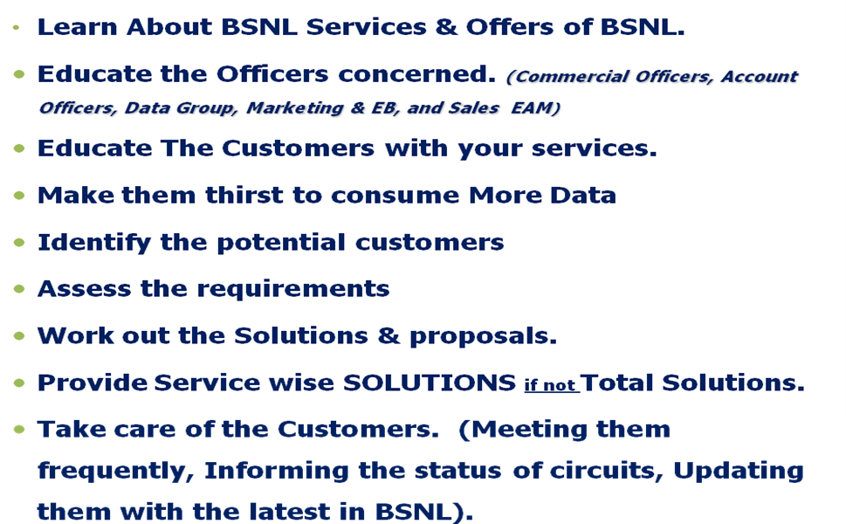

- Identify the requirements of the customers.
- Work out the solution.
- Know about the prevailing competitive scenario.
- Tell the +S, Premiums of BSNL.
- Start with Technical Discussion and Close the deal with commercials.
- Business Nothing But Relationship
- You make the impact of BSNL and You on Customer
- You are the face of BSNL from the customer’s view.

What we should not do?

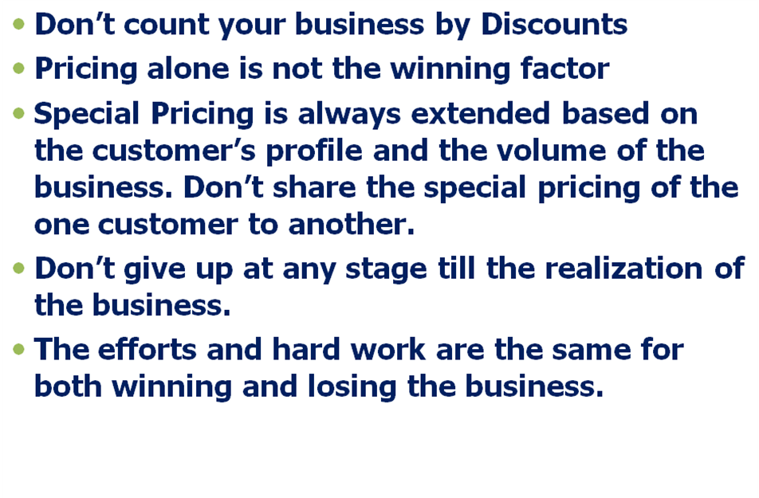
Please remember:
- Let us have positive mindset of our services.
- Our services are premium services and our rates are competitive.
- QoS and other service level attributes are key factors for the decision making from the customer’s point of view.
- APPLE to APPLE Comparison – Industry Trend )
TO IMPROVE USO REVENUE:

1. Ten MCUs free per month per VPT can be best utilized by SSAs, by making vide
publicity of this 10 free calls concept to all VPT custodians and ensure at least
one call is made per VPT per month, and ascertain the meter reading every month
and thus per Quarter to claim full/maximum subsidy without any loss.

2. DNP VPTs >3months should be restored by relocation.Outstanding dues should
be collected at least in easy installments from custodians without fail.

- Post paid CDMA VPTs should be converted to prepaid CDMA VPTs and thereby no
data, ZMR ( Zero meter reading ), DNP etc are avoided and 100% functionality of
VPT shall be ensured by field staff by frequent visits. ARPU of VPT also can be
increased as targeted by Corporate Office and subsidy also can also be assured
for these VPTs.

- New VPTs provided as per New VPT agreement and census 2001 should be maintained very scrupulously, because Rs.25,000/- FLS ( front loaded subsidy ) we have received per VPT and Rs.790/- EAS (Equated Annual Subsidy) per VPT should be ascertained /assured by SSAs. (Eligible for 5 Years from Date of Installation). All New VPTs should be moved to commercial location (even in less than 100 population villages ) as far as possible ultimately, to maintain agreement conditions and functioning of SPV panel to WLL VPTs should be monitored carefully since we have received Rs.6,250/- per SPV per WLL VPT (included in Front loaded subsidy).

- Among New VPTs, DSPT VPTs working in Salem SSA and Dharmapuri SSA should be carefully maintained for another 5 years from the date Of Installation, since we have claimed Rs.1 Lakh FLS (Front Loaded subsidy) per DSPT VPT. Total 2 Lakhs received this year (EAS Rs.2,735 per Quarterly for 5 years).

- Regarding Rural Broad Band provision the target was fixed by Corporate Office this year, for connection, Nova Pcs and kiosk provision. All SSAs should try to achieve the target in full so that maximum subsidy component can be achieved in full on respect of Rural Broad Band agreement. For a connection, we get (4500 Fls +850 modem) Rs.5350/- on provision and maintenance subsidy of Rs.200/- approximately per Quarter for 2 years from Date Of Installation,. For one kiosk we get Rs.20,000/- equated quarterly subsidy per Quarter and we continue to receive for 3 years from Date of Installation for maintaining. Kiosk should be kept opened between 0800 AM to 0400 PM and wherever provided in Rural Exchanges, leakage of revenue should be avoided and monitored closely by viewing CDR billing every month. Nova PCs closure should be intimated to vendor every month by BSNL local authorities and Pcs should be recovered from closure connections and provided to NPCs every month since PCs are claimed on net addition basis. Otherwise vender has to lose the amount already claimed, for closure connections with Pcs.’ Corporate Office also should Co-operate and coordinate regarding the issues/clarification raised by Circle and in clearing the dues/claim from DOT Cell in coordination with USOF (A) for quick settlement of subsidy claimed by circle.

Regulation wing – To curb leakage of revenue

- IOBAS migration to CDR Platform

- Attend the IOBAS TIME GAPs which is issued twice in a month in IOBAS Web Portal (22nd and 3rd ) by POI-in-charges without fail. Non verification of IOBAS time gaps will lead to loss of revenue to BSNL and delay in raising INVOICES by Data Centre, Hydrebad.

- Run the CDRAS Software on 2nd of every month and enter the Call Count / MOU in ‘ MOU details’ of CDR Portal on the same day itself.

- Compare the Pre-Estimate invoices issued by IOBAS with CDRAS output every month. Any discrepancy should be brought to the notice of IOBAS wing to avoid supplementary invoices.

- The final Invoice of all OLOs should verified with previous month invoice and any short fall must analysed to arrest revenue leakage.

- Two certificates in respect of attending the IOBAS TIME GAPs and Running of CDRAS should reach DGM (Regulation ) office on 5th of every month.

- The TGP particulars of OLO (both I/C & O/G ) available at IOBAS web portal should be verified to avoid revenue leakage.

- Port and Infra charges
The details of Port availability of OLOs with DOC/DOS is required for updating and for raising the Annual Rental Claim. In most of the SSAs there was short billing by clubbing of Ports taken by the Pvt. Oprs. This should be verified and if any detected, the same may be billed immediately and recovered under intimation to Regulation wing to avoid loss in revenue.
- Equipment details and Duct Sharing by OLOs
- In most of the field, the actual consumption is reported as the rated power supply and also claim raised only for this. Charges are different based on Amps. Upto 10Amps -Single: 10>20Amps it is doubled; the charges are to be claimed for maximum capacity of the equipment. The same has to be verified and any short billed , n/a action should take to raise and recover the Miscellaneous Charges for the maximum capacity of the equipment.

- The equipment details of OLOs ,Duct sharing for both active and passive links, No. Of Bays used in the System, and Leased Line details are to verified and updated for raising the annual rental claims to avoid any loss to BSNL .

- Cable damages caused by Private Operators.
In most of the cases, where the BSNL cables were damaged by the Contractors of the OLOs the cable damages claim were raised, acceptance certificate from the contractor had not received. There was a dispute in number of cuts. For a single cut of OF cable, the claim is RS.1,50,000. Hence, the certificate from the Contractor is very much essential and the same must be received on the occurrence itself.
- POSTING OF SDEs (Nodal Officers) EXCLUSIVELY FOR NC / IOBAS ACTIVITIES.
One SDE may be posted at each SSA Heads exclusively to Co-ordinate with POI-in Charges and TR Wing to Co-ordinate the above activities thereby to avoid revenue leakage and at the same time to realize the revenue in time.

- Signalling Charges which has raised against OLOs. The case is under subjudice. Since the outstanding amount is very huge, action may be taken at corporate office level to speed up the cases .
- UASLs are using our expensive CCS7 resources for SMS services. For this claims are yet to be raised.
General:

- AMC for the new tech Exchanges at should be stopped and it will be well maintained by our staff.

- Vellore SSA is already having a C-DOT card repair centre and now they are extending the facility of repairing ADSL modems also. This may be followed in other SSAs also. Similarly to attend P/P module faults, AC Unit fault, AFD faults, instead of outsourcing a team has to be formed at SSA level to rectify the same to curtail expenditure.

- Instead of scrapping all cells of life expired batteries, good cells has to be preserved to replace the faulty one at needy places.
- WI-Max has to be commissioned at the earliest
- To avoid expenditure, process for ISO recertification / renewal and all ISO related activities are to be stopped, as per the instruction of the Corporate office.
- Staff at office may be utilized for sales and marketing so that the TMs working in Sales Teams may utilized at needy places for maintenance purpose.
- ATD for leased ccts to be raised without fail for all ccts.
- Exclusive areas where there is only BSNL coverage should be identified and
concentrated for sim sales at those areas.
- All our recreation clubs, conference halls may be given for outsiders for conducting meetings on rental basis.
- BSNL products ( SIM cards / Vouchers / GSM FWP instruments etc.) shall be issued to staff for sales at concession rate or on incentive basis. Willing officials can promote business. This will also motivate our staff.

- Billing problems in Video on Demand services. Facility is provided by default to Broad Band customers. Procedure for canceling this service by customers is very cumbersome.
- Students Economic Plan Data Cards - Economic plan data cards with low price should be planned. Tamilnadu government is going to issue free LAPTOP to students.

